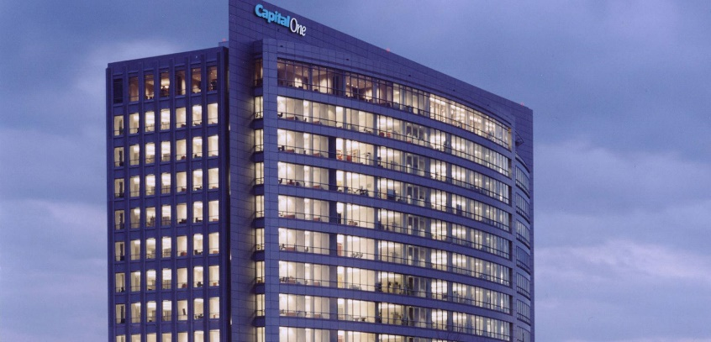
Host/Location:
Capital One, McLean 2 Bldg.
1600 Capital One Drive
McLean, VA 22102
Mapquest: Click here for directions to Capital One, McLean VA
Goggle Maps: Click here for directions to Capital one, McLean, VA
Parking: FAR Committee Members will park in the lot adjacent to 1600/McLean 2 Building. Upon arrival at McLean 2, they will check in at the Lobby Security Desk. Members of the Not-For Profit Group will escort them to the Conferencing Center on the 6th floor. (Please have the Committee Members present their parking ticket to Christine Cardinal, the tickets will be validated and returned to them at end of the meeting)
Additional parking is available in the overflow parking lot located at 1750 Old Meadows Road (across the street from Capital One).
Overflow Parking Shuttle: Take the Overflow Route shuttle between 1600 and1680 Capital One Drive and the Old Meadow Road garage—less than 10 minutes door-to-door. The Overflow Parking Shuttle will run continuously between 8 a.m. and 6:30 p.m.- look for the “Shuttle Pick-up” sign in front of the garage
See map for location of Capital One Overflow Parking Garage.
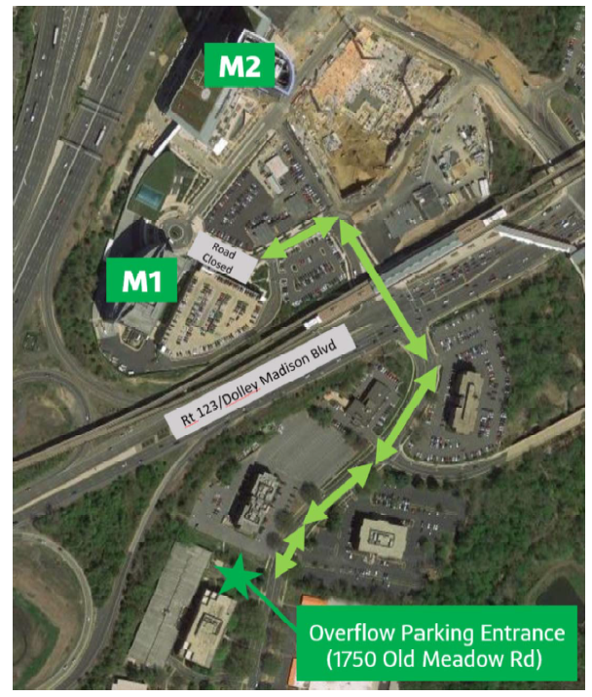
Metro: McLean Station (see map)
From McLean Station: Take Silver Line (Wiehle Reston East) to McLean Station. Exit McLean Station, heading South and walk approximately 0.2 miles to corner, then make a right onto Capital One Drive. ***Please note: Shuttle Info***

